Bellmore-Merrick CHSD

Electrical Training Program
BELLMORE-MERRICK
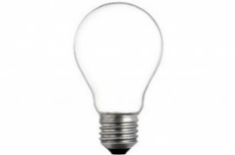
CENTRAL HIGH SCHOOL DISTRICT

2023-2024 BMCHSD Electrical Training Program
Parent Open House and Information Night
for incoming Juniors

Monday, December 12th at 6:30pm
In the Brookside Electrical Lab
1260 Meadowbrook Road
Merrick, NY 11566

Meeting Agenda Will Include:

- Overview of the New 2-Year Electrical Training Program
- 900 Hours
- Renewable Energy & Green Energy
- Micro Credentialing from Manufacturing Training
- Heat Pump Technology
- Fire Alarms, Generators
- Transition from Training to Careers in Electrical Field

