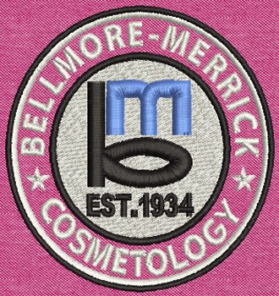

BMCHSD Cosmetology Showcase
Meet, Greet, and Mingle with current and future professionals in the industry. Experience modern day salon services performed right here by our Cosmetology Students. Be a part of our art!
Visitors and clients will have the opportunity to observe and receive services from one of the various beauty stations:
- Shampoo, Condition and Scalp Massage
- Blow dry styles
- Hot iron style- (your choice of curling or flat iron with a heat protectant product)
- Day time makeup application
- Manicure with or without polish
- Specialty braiding: Dutch, French, fishtail, on -the-scalp and more...
- Paraffin treatment of the hands
- Gel manicures
- Eyebrow Shaping and Cleanups
- Brow and Lash Tints
- Henna applications

Location: Calhoun High School- Cosmetology Wing, B-273
Sessions: 8:00am-9:30am & 12:00pm-1:30pm
Attendees: salon & beauty professionals, cosmetology teacher, prospective students, current cosmetology students, friends and family members of the community. All are welcome!
Please join us for the Annual BMCHSD Cosmo Showcase on December 22nd!

